Use Case: Order Transaction

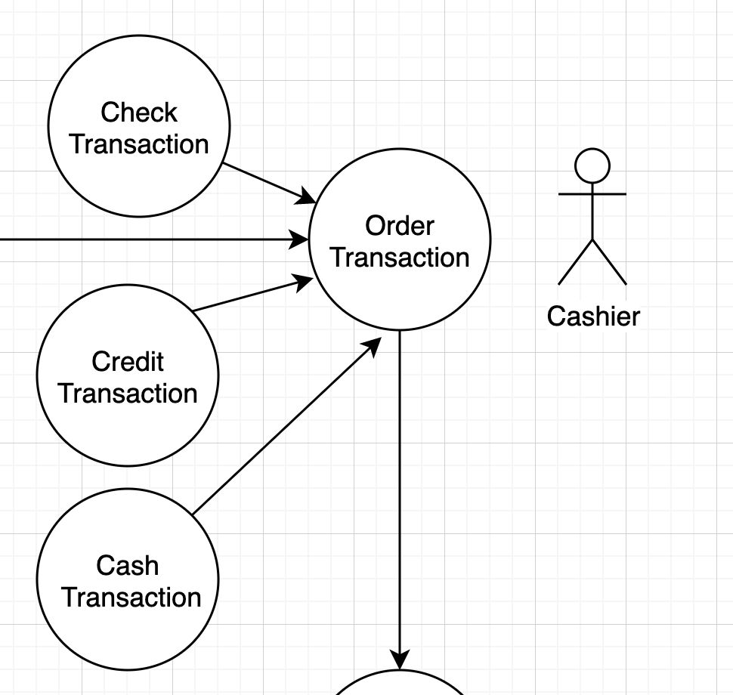

**Priority:**3  
**Actors:** Cashier  
  
**Summary:** Running the transaction through the transaction processing system

**Preconditions:**Customer placed an order with items  
  
**Post-Conditions:** The transaction is ready to be completed  
  
**Uses:** Record Transactions  
  
**Extends:** None  
  
**Normal Course of Events:**

1. The use case starts when the Customer places an Order
2. The cashier selects the appropriate type of transaction for the customers payment method
3. The cashier then fills in all required fields and processes the transaction

**Exceptions:**

1. The system will not allow a user to process a transaction that is not available

**Assumptions:**

1. The system is pre-defined by management to only accept the correct payment types for the business.

Use Case: Run Reports

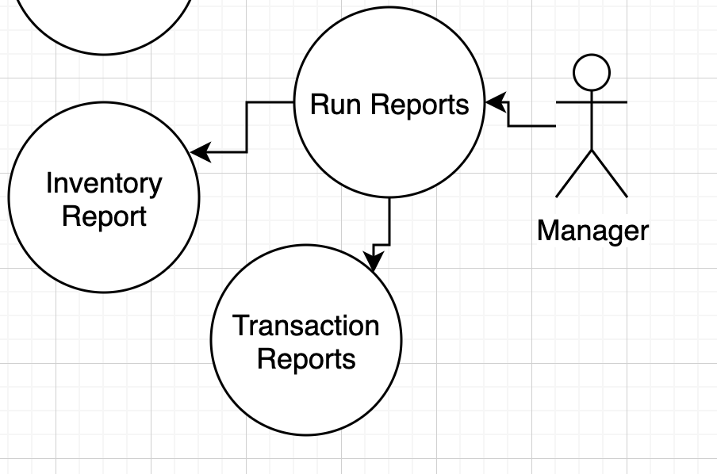

**Priority:**2  
**Actors:** Manager  
  
**Summary:** Running reports on transactions and inventory

**Preconditions:**Customer placed an order with items and the Cashier ran the transaction  
  
**Post-Conditions:** The report is generated  
  
**Uses:** Run Reports  
  
**Extends:** None  
  
**Normal Course of Events:**

1. The use case starts when the Manager generates a Report
2. The Manager selects a type of report to run, either Inventory or transaction
3. A report will be generated and displayed to the Manager

**Exceptions:**

1. The system will not allow a user to process a report that is not available

**Assumptions:**

1. The system is pre-defined by management to only display reports that are correct for the manager to see

Use Case: Place Order

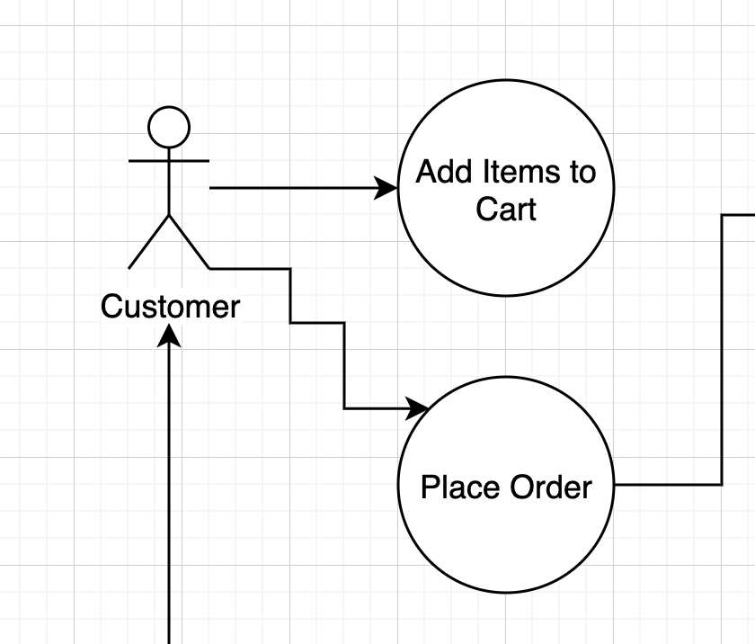

**Priority:**2  
**Actors:** Customer  
  
**Summary:** Add items to cart and place order

**Preconditions:**Items are available for the customer to add to cart  
  
**Post-Conditions:** The order is placed  
  
**Uses:** Place Order  
  
**Extends:** None  
  
**Normal Course of Events:**

1. The use case starts when Customer adds items to Cart
2. Once the customer finishing placing items into the cart the users the Places Order

**Exceptions:**

1. The system will not allow a user to select items that are not in inventory

**Assumptions:**

1. The system is will display products that are in inventory. Back-ordering is prevented

Use Case: Complete Transaction

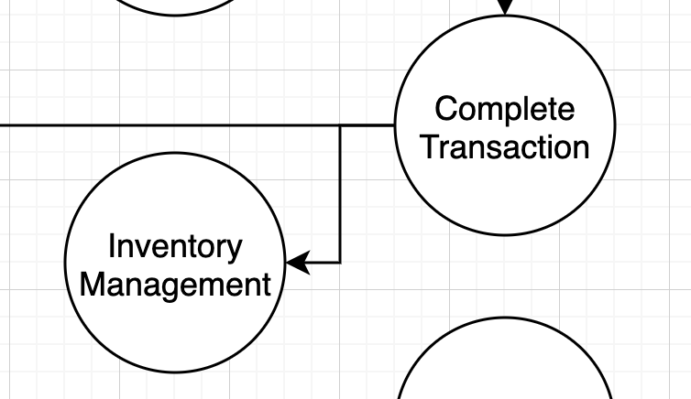

**Priority:**3  
**Actors:** Cashier  
  
**Summary:** Completing the transaction through the transaction processing system

**Preconditions:**Customer placed an order with items and the transaction data was entered correctly  
  
**Post-Conditions:** The transaction is recorded and a receipt is generated  
  
**Uses:** Record Transactions  
  
**Extends:** None  
  
**Normal Course of Events:**

1. The use case starts when the Cashier finishing entering the transaction details
2. The Cashier fills in any other required field like customer information or shipping information
3. The Cashier then Completes the Transaction.
4. The system then generates the receipt and send to customer
5. The system deducts the products ordered from the Inventory

**Exceptions:**

1. The system will not allow a user to process a transaction that is not ready to complete